TEAMER 13 Final Report 2025-0042 Simulink data_README.docx

Data and models used in Simulink model of C-Power StingRAY power system.
To run the model, copy the files/folder below into a folder. Open MATLAB 2024b or later.
- Folder ov_original_data
  - Contains MATLAB file N7638cs81.mat, the wave data set with the highest velocity waves. To analyze other data, move the appropriate *.mat file to this directory and change the filename called within Init_PMSG_System.m.
- MATLAB file: Init_PMSG_System.m
  - MATLAB file that initializes different parameters for Simulink model PMSG_System_18May2025.slx.
  - Determines which *.mat file that wave velocity data is extracted from. Default is the set with the highest velocity waves, which produces voltages that cause overvoltage trips: N7638cs81.mat, which is located in folder ov_original_data. It also selects which period of time within that wave data are analyzed. It currently selects a 12-second portion from sample 16431 to 16550, which is a period with speed exceeding 10 RPM.
  - Sets parameters for all components to align with the system as described in the report.
- MATLAB Simulink File: PMSG_System_18May2025.slx
  - Detailed Simulink model of the StingRAY power system as described in the report.
  - Contains the following main blocks:
    - PMSG – the model of the Permanent Magnet Generator. Here the user can select wave data or a simple sine wave as speed input to the generator by commenting out the source that’s not used and connecting the source that is used to the absolute value block labeled |u|. Below shows the setup of the “Select RPM Source” block with the sine wave commented out and the wave data connected.
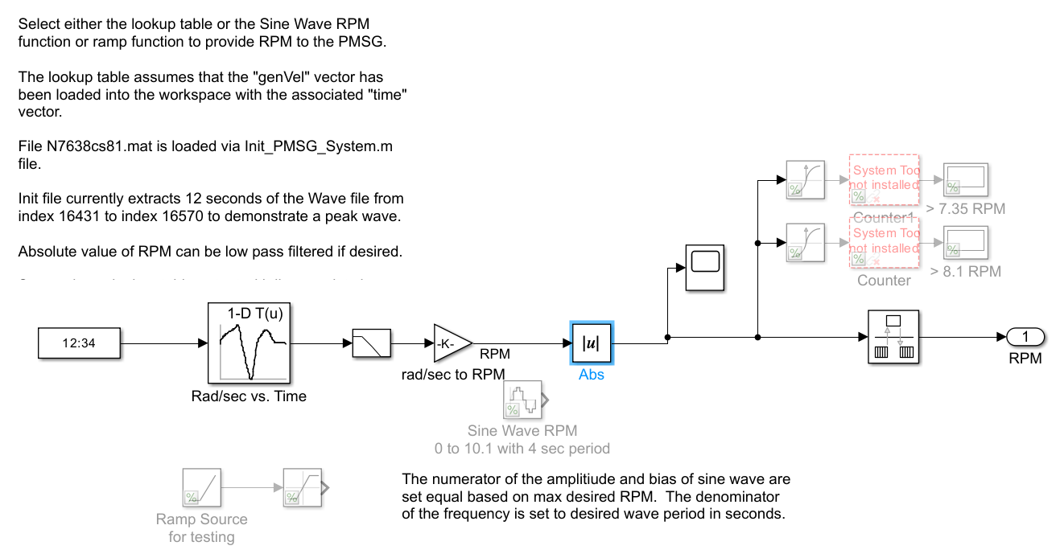
    - AC/DC Converter – This is the model for the AC/DC rectifier used to extract energy from the PMSG. It uses Simulink’s standard Average-Value VSC (voltage source converter) to model the rectifier. The Outer loop id iq control block within the Field Oriented Control block is where flux weakening can be implemented. Per the report, it is designed to kick in 7.35 RPM. It can be disabled by disconnecting the output of the “Enable flux weakening. Switch at 7.35 RPM” block from the multiplexer in front of the idq_ref output port and upper scope multiplexer then connecting a constant zero block in its place.
      - Flux weakening enabled shown here:
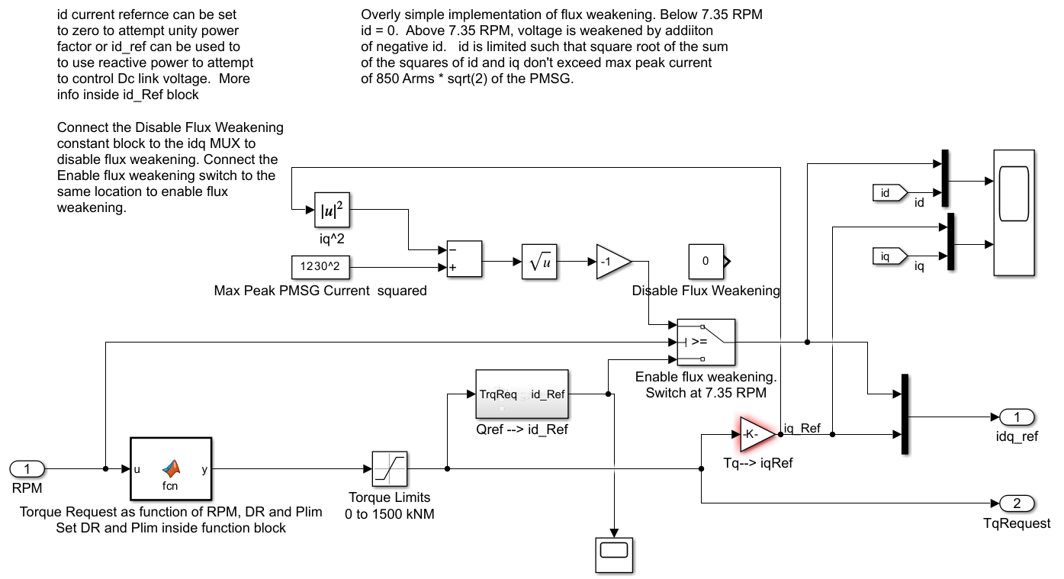
      - Flux weakening disabled shown here:
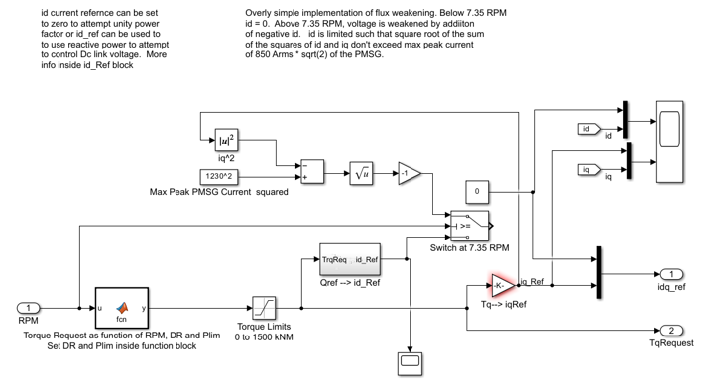
    - Dynamic Braking Unit
      - Models the Dynamic Braking Chopper using Simulink’s One-Quadrant Chopper block feeding a resistor. Controls are set to kick in at a prescribed DC link voltage. Incorporates controls to limit power to an average of 25% of rated power.
    - Inverter and Grid Tie
      - Models the interface to the power grid using Simulink’s Average-Value Voltage Source Converter Block (Three-Phase), circuit breaker, step-up transformer and nominal load.
    - BESS Current Control
      - Models the Battery Energy Storage System using Simulink’s Bidirectional DC-DC Converter block and a battery matching the StingRAY’s system parameters.
    - System Control Block
      - Overall system controls are implemented within this block. Subsystems are Grid CB Close Logic, PMSG CB Logic, DBU Logic, Inverter Current Control, BESS KW Control, and Torque Monitor.

